**10 SCIENCE 2015**

### CHEMISTRY TEST TWO ESL

Name: ____________________ Mark: /50

**SECTION A: MULTIPLE CHOICE (15 marks)**

Please answer on the answer grid below.

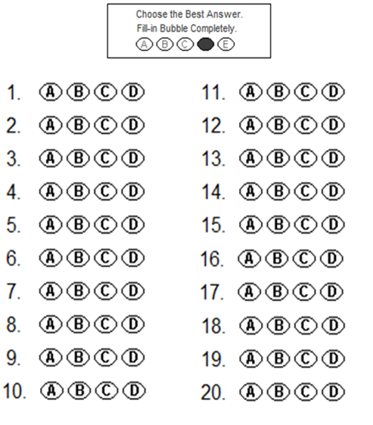





**1.** For ionic bonding, the different ions are held together due to a:

(a) Difference in State.

(b) Difference in charge.

(c) Sharing of electrons.

(d) Sharing of protons.

**2.** Elements are:

(a) pure substances made of only one type of atom.

(b) charged particles.

(c) two or different types of atom chemicaly combined.

(d) all metals.

**3.** Choose the correct definition for ‘ions’.

(a) Particles that have the same number of protons and electrons.

(b) Particles that have no charge.

(c) Particles that have more neutrons than protons.

(d) Particles that have a charge.

**4.** The correct name for the compound NaCl would be

(a) Natural chloride.

(b) Potassium chloride.

(c) Sodium chloride.

(d) Sodium chlorine.

**5.** Lead Iodide would have the formula:

(a) PbCl.

(b) PbI2.

(c) FeCl.

(d) LI.

**6.** A chemical equation shows:

(a) The number and type of elements in one molecule of a compound.

(b) The reactants and products in a chemical reaction.

(c) The different states of matter that a compound can exist in.

(d) The amount of energy released in a chemical reaction

**7.** A chemical formula shows:

(a) The number and type of elements in one molecule of a compound.

(b) The reactants and products in a chemical reaction.

(c) The different states of matter that a compound can exist in.

(d) The amount of energy released in a chemical reaction

**8.** The materials made in a chemical reaction are called the:

(a) reactants.

(b) resultants.

(c) products.

(d) Ions.

**9.** If Lithium atoms lose one electron they will become:

(a) elements.

(b) negative ions.

(c) positive ions.

(d) Non-metals.

**10.** Nitrogen, chlorine, hydrogen and oxygen all form.

(a) noble gasses.

(b) Poisons gasses.

(c) diatomic gasses.

(d) inert gasses.

Look at the particle in this diagram and use it to answer questions 11, 12 and 13.

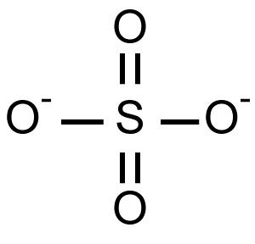

11. The particle above is an example of a/an:

(a) radical ion.

(b) neutral ion.

(c) element.

(d) metal

12. The particle is called:

(a) sulphate ion.

(b) sodium ion.

(c) Oxide ion.

(d) Phosphate ion.

13. Which of the following would be attracted to the particle in the diagram?

(a) Oxide ion.

(b) Chloride ion.

(c) Nitride ion.

(d) sodium ion.

14. Which of the compounds below will have the most oxygen atoms in one molecule?

(a) Al2O3

(b) CO2.

(c) Cr2(SO4)3.

(d) Al(NO3)3

15. Which of the compounds below has the largest number of different elements in each molecule?

(a) Al2O3

(b) CO2

(c) Cr2(SO4)3

(d) Al(HCO)3

**SECTION B:**

**1.** Balance the equations below. (8 marks)

**a.** Na + Cl2 🡪 NaCl

**b.** Al + O2 🡪 Al2O3

**c.** Al + Cl2 🡪 AlCl3

**d.** H2 + O2 🡪 H2O

**e.** C3H8 + O2 🡪 CO2 + H2

**f.** Fe2O3 + C 🡪 CO2 + Fe

**g.** Al + HCl 🡪 AlCl3 + H2

**h**. Ca + H2O 🡪 Ca(OH)2 +H2

**More question on next page**

**2.** Work out the formula for the ionic compounds listed below.

|  |  |  |
| --- | --- | --- |
| Name | Working | Formula |
| Sodium chloride |  |  |
| Calcium Iodide |  |  |
| Silver sulfide |  |  |
| Iron(III)oxide |  |  |
| Iron(III) Iodide |  |  |
| Chromium sulfide |  |  |
| Zinc sulfide |  |  |

**(7 marks)**

**3. For some compounds we need to know the formula. Write the formula for these.**

|  |  |
| --- | --- |
| **Name** | **Formula** |
| **Water** |  |
| **Carbon dioxide** |  |
| **Oxygen gas** |  |
| **Chlorine gas** |  |

**(4 marks)**

**4. For the elements listed below write the number and type of elements in one molecules of the compounds listed.**

|  |  |
| --- | --- |
| Compound formula | Number and type of elements present in one molecule of the compound |
| **Fe2O3** |  |
| **C3H8** |  |
| **CCl4** |  |
| **C6H12O6** |  |

(8 marks)

5. Rewrite the word equations below as balance formula equations.

(8marks)

Lead Oxide + Carbon 🡪 Carbon dioxide + Lead metal

Iron metal + oxygen gas 🡪 Iron oxide

Potassium metal + chlorine gas 🡪 Potassium chloride

Potassium metal + water 🡪 Potassium Hydroxide + Hydrogen gas

**Table of common ions**

|  |  |
| --- | --- |
| **+1 charge** | **- 1 charge** |
| Hydrogen H+  Lithium Li+  Sodium Na+  Potassium K+  Copper (I) Cu+  Silver Ag+  Ammonium NH4+ | Fluoride F-  ChlorideCl-  Bromide Br-  Iodide I-  Hydride H-  Hydroxide OH-  Nitrite NO2-  Nitrate NO3- |
| **+2 charge** | **- 2 charge** |
| Manganese Mn2+  Magnesium Mg2+  Calcium Ca2+  Barium Ba2+  Zinc Zn2+  Copper (II) Cu2+  Mercury (II) Hg2+  Iron (II) Fe2+  Tin (II) Fe2+  Lead (II) Pb2+  Nickel (II) Ni2+  Beryllium Be2+ | Oxide O2-  Sulfide S2-  Carbonate CO32-  Sulfate SO42-  Sulfite SO32- |
| **+3 charge** | **- 3 charge** |
| Aluminium Al3+  Iron (III) Fe3+  Chromium (III) Cr3+  Boron B3+ | Nitride N3-  Phosphate PO43-  Phosphide P3- |